UML DIAGRAMS

CLASS DIAGRAM

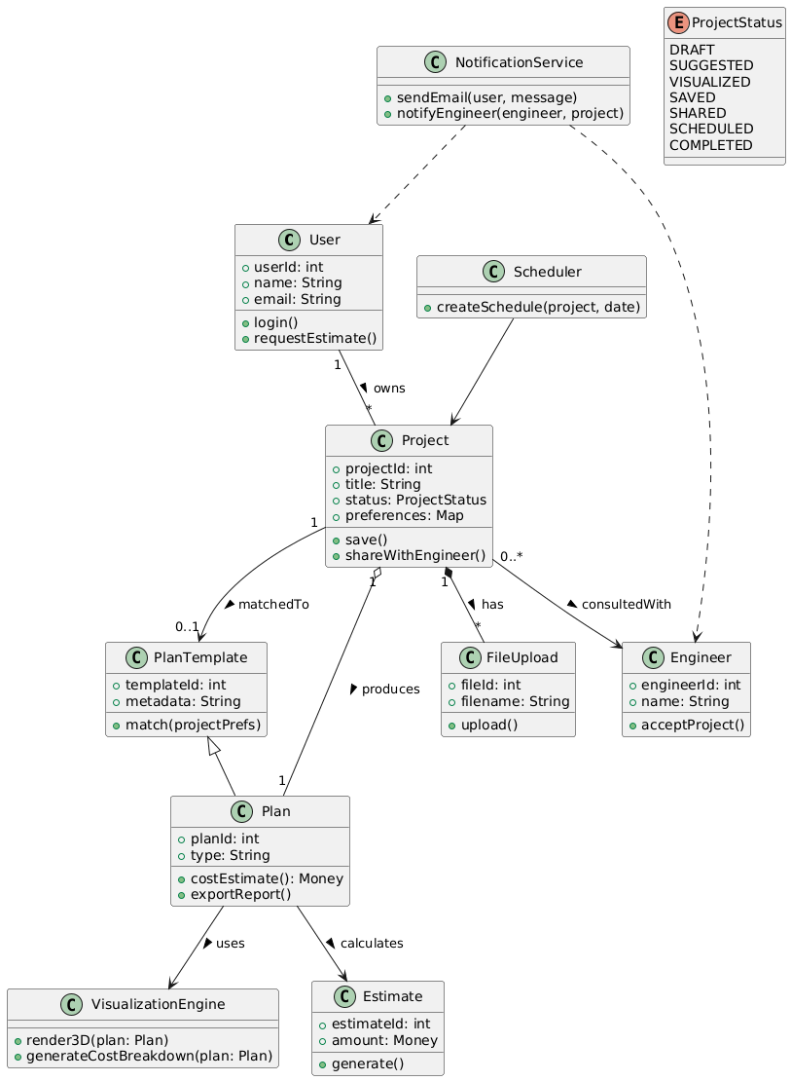

COMPONENT DIAGRAM

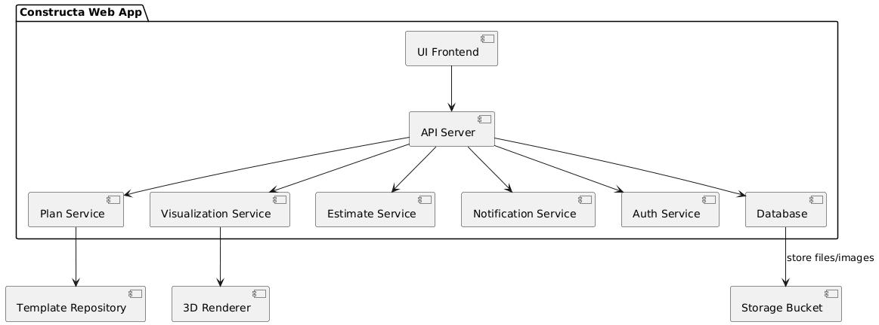

DEPLOYMENT DIAGRAM

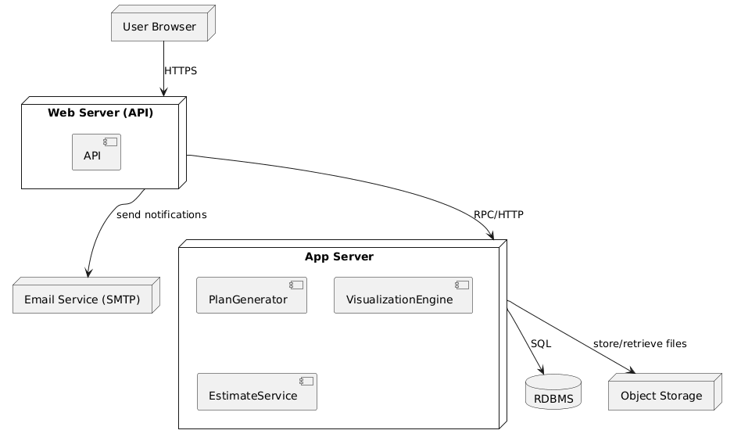

STATEFUL CHART DIAGRAM
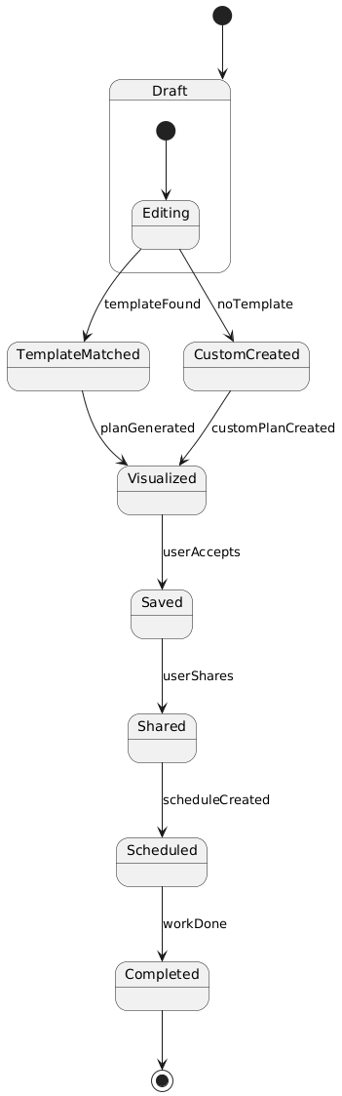

USE CASE DIAGRAM

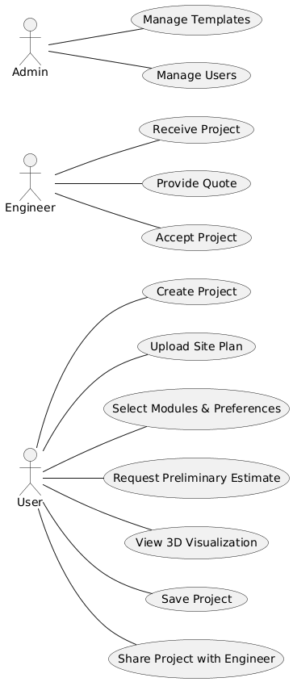

SEQUENCE DIAGRAM

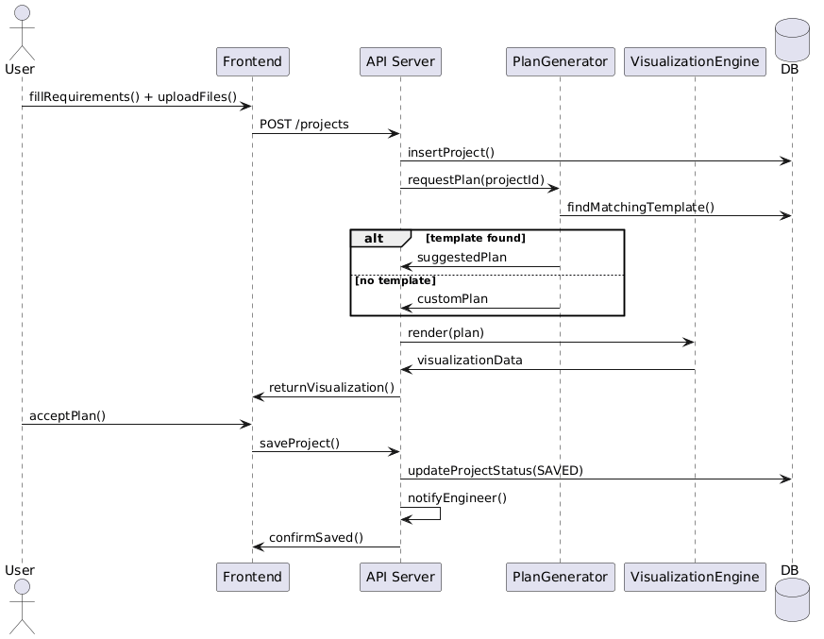

OBJECT DIAGRAM

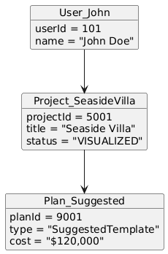

ACTIVITY DIAGRAM

